CENWP-OD-B 17 July 2023

MEMORANDUM FOR THE RECORD

SUBJECT: 23BON058 MFR AFF Valve 15 PL Morts and Smolt Chinook Mort

On the morning of 17 July, Columbia River Inter-Tribal Fish Commission (CRITFC) Biologists notified Bonneville Project Biologists of five Pacific Lamprey mortalities, two juvenile salmonids, and one Sockeye found on the Valve 15 trash rack in the Adult Fish Facility (AFF). The fish were scanned for PIT tags, inspected, and returned to the river.
#1
- Species – Pacific Lamprey (Entosphenus tridentatus)
- Origin – Unknown
- Length – In descending order: 64.8 cm, 69.9 cm, 67.3, 66.7, 69.9
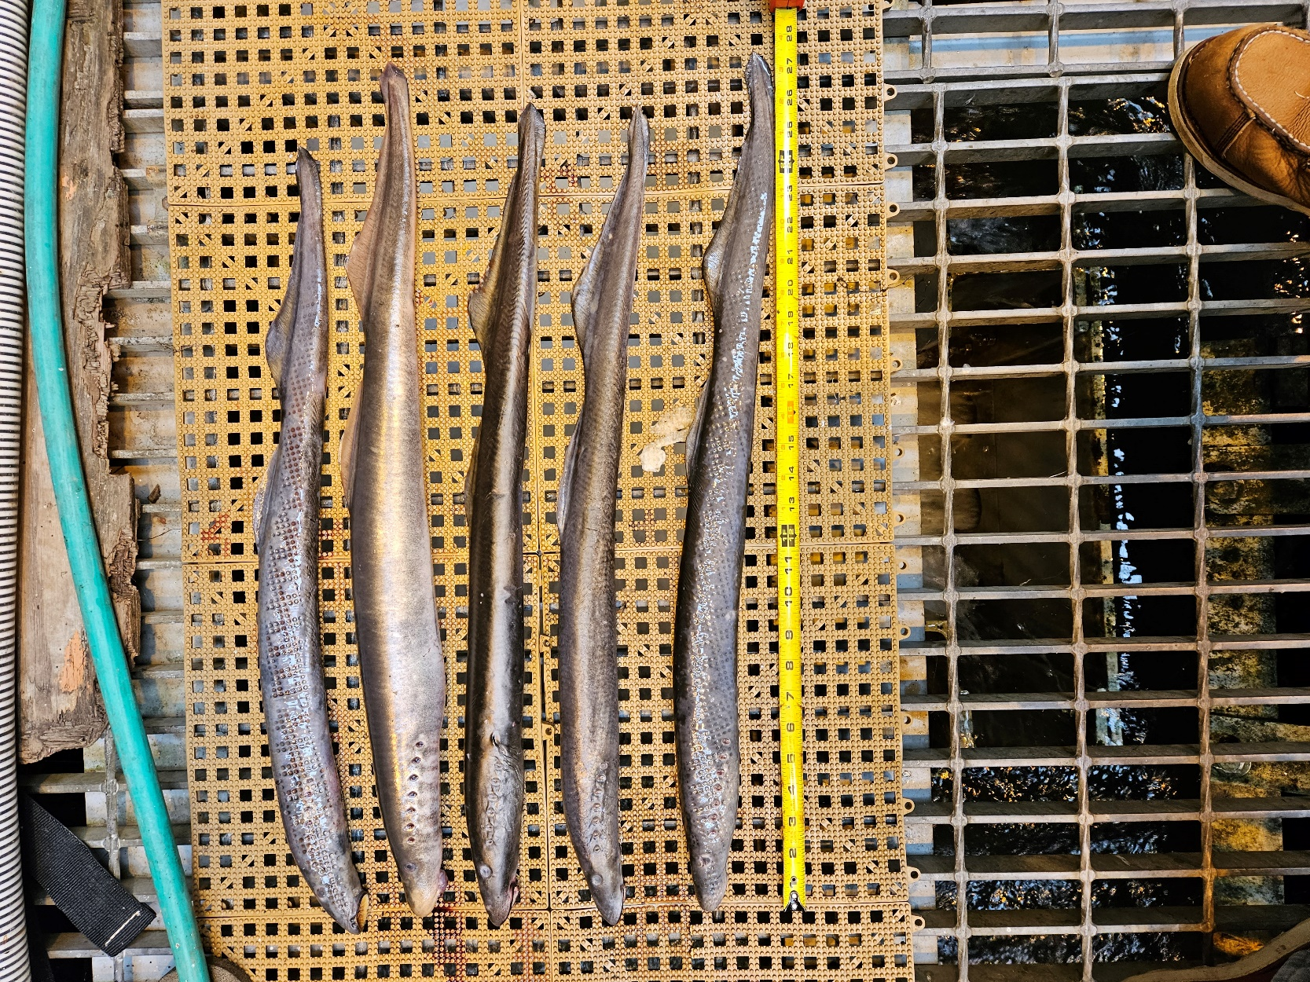
- Marks and tags – None
- Marks and Injuries found on carcass – None
- Cause and Time of Death – Unknown
- Future and Preventative Measures – None
#2
- Species – Juvenile Salmonids
- Origin – Unknown
- Length – In descending order: 23.5 cm, 21.6 cm
- Marks and tags – None
- Marks and Injuries found on carcass – Large laceration above head, possible predation wound
- Cause and Time of Death – Possibly avian predation
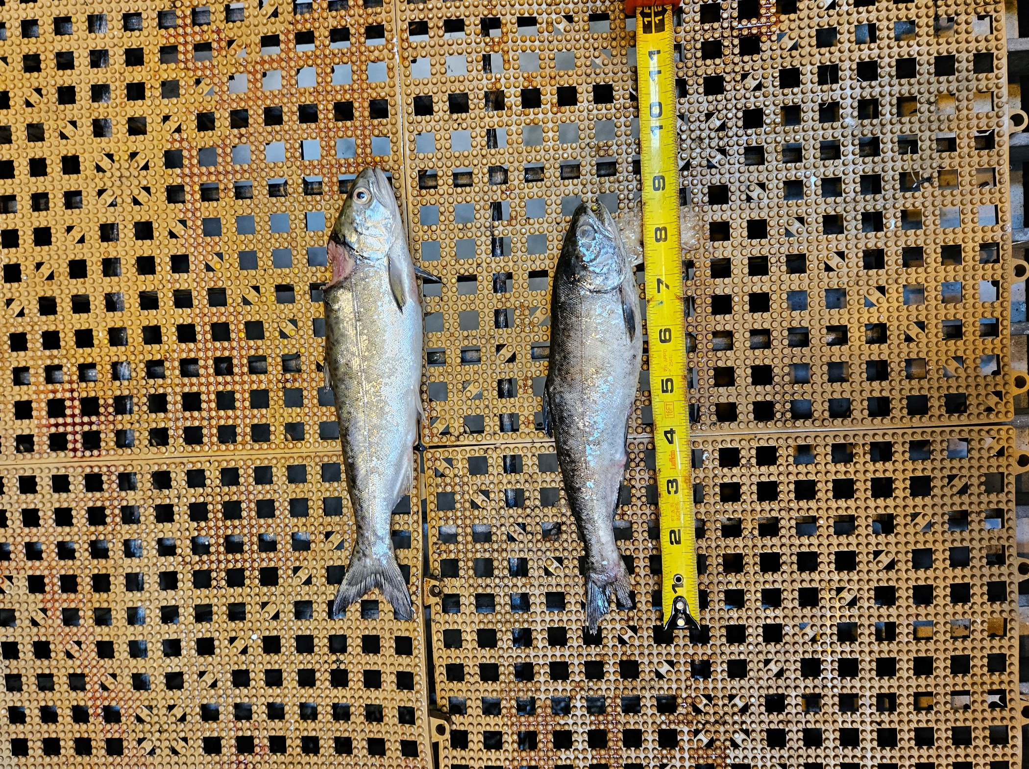
- Future and Preventative Measures – None

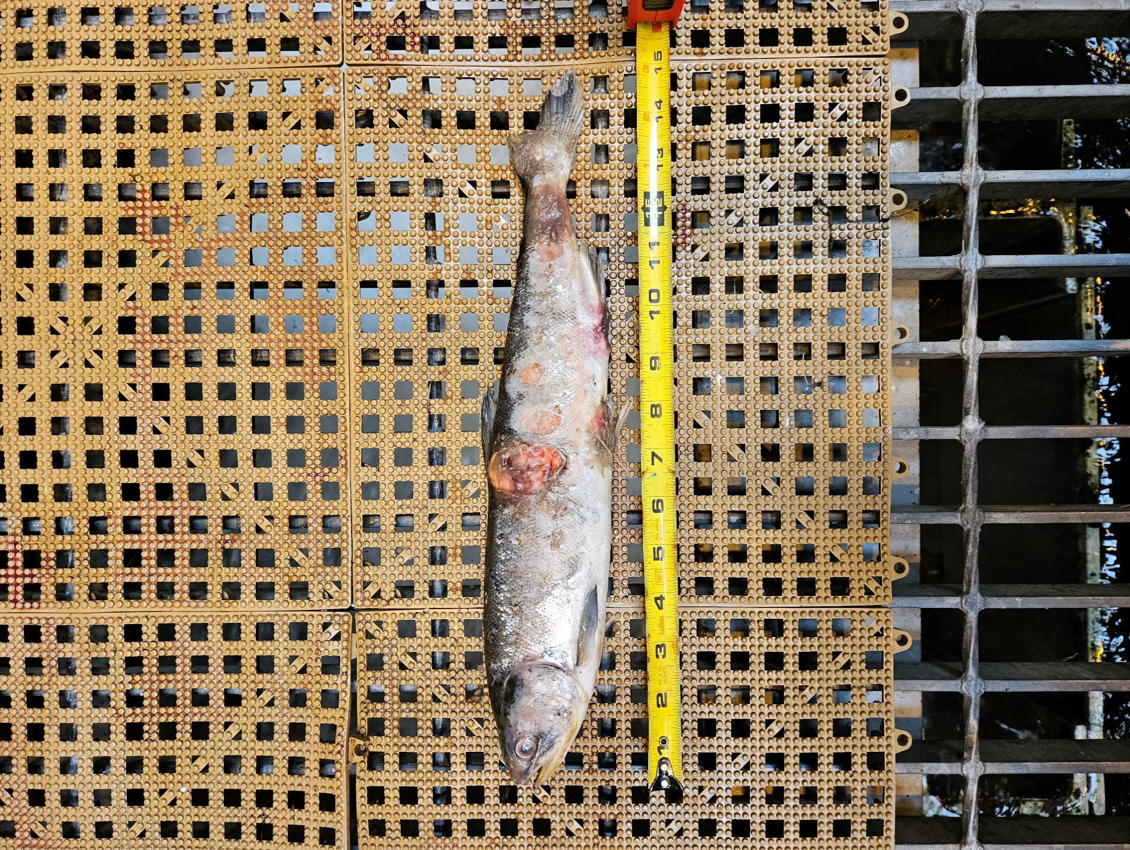
#3
- Species – Sockeye (Oncorhynchus nerka)
- Origin – Unknown
- Length – 38.1 cm
- Marks and tags – None
- Marks and Injuries found on carcass – Lacerations along the lateral line
- Cause and Time of Death – Possible avian predation
- Future and Preventative Measures – None

Sincerely,
Bonneville Project Fisheries

